

**Whiston Parish Church – Children and Families – Spring/Summer 2017**

Children and Families at Whiston have been having a wonderful time.

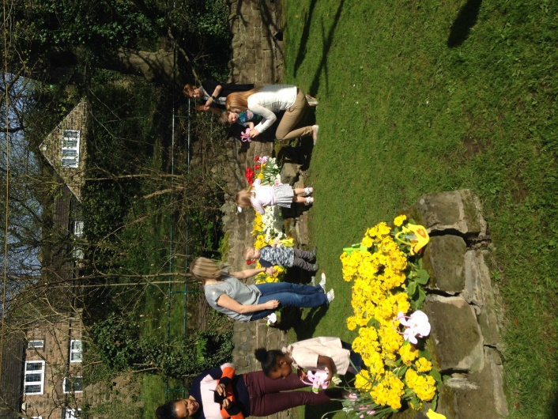

**Little Fishes**

The families that attend Little Fishes have enjoyed meeting weekly. This is a photograph of some of the families enjoying an Easter Egg Hunt. We also met in Church just before Easter which fell the week after Mothering Sunday so we had a celebration for all the Little Fishes Mums.

We continue to enjoy weekly bible stories, prayertime and songs.

Recently we held a Sponsored Toddle and Teddy Bears Picnic.

We will be meeting in Church next Monday and Tuesday mornings as our last sessions before the summer break.

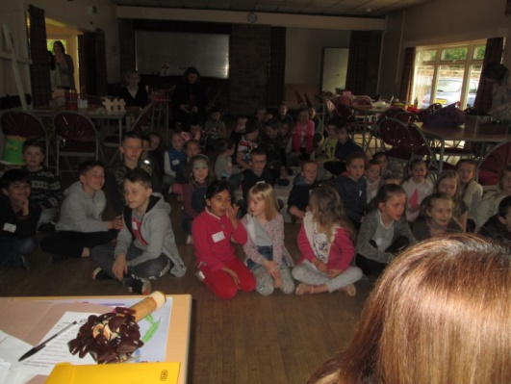

**Good Friday Awesome Activities**

We had a fantastic day on Good Friday when we saw record numbers of children attending the fun session which included a short film of the Easter story, crafts including Easter gardens, baking, woodland walk and den making, fish and chips and more.

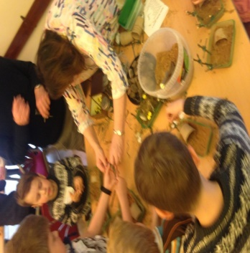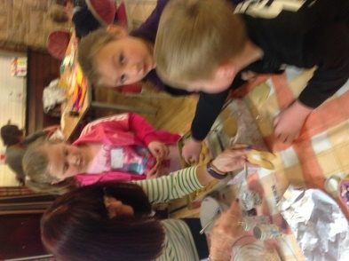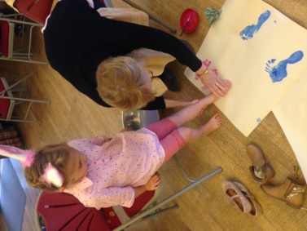

**School’s Out Activity Day**

Another super day at the Cricket Club in May with just over 20 children attending. The theme of the day was being kind to each other. The Cricket Club is a fantastic venue and enables lots of outdoor activities.

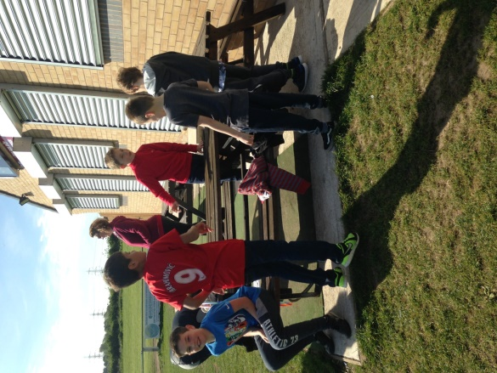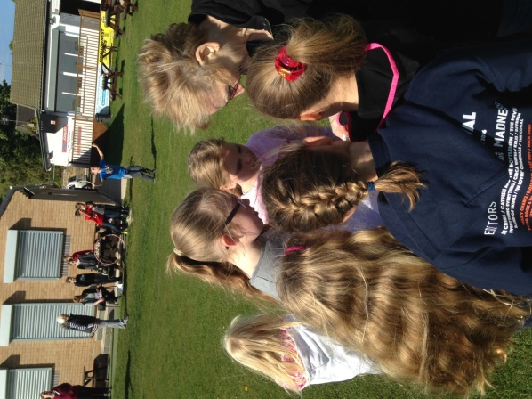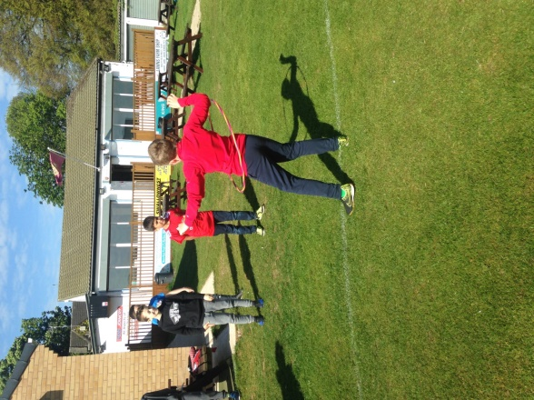

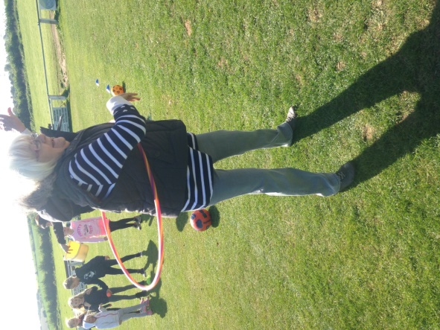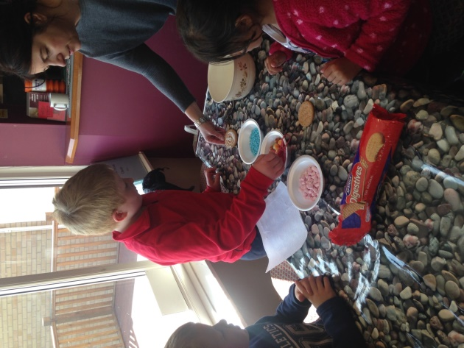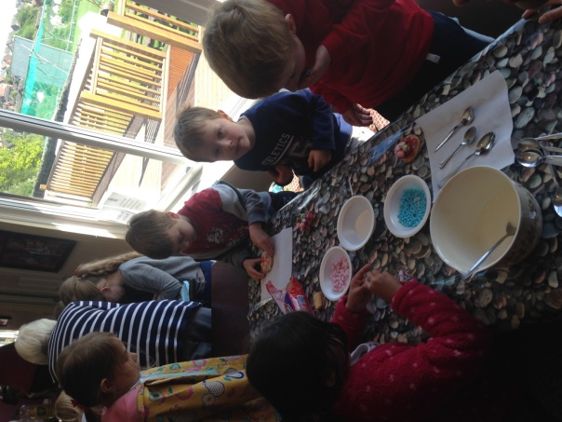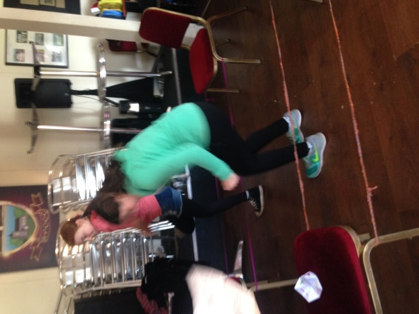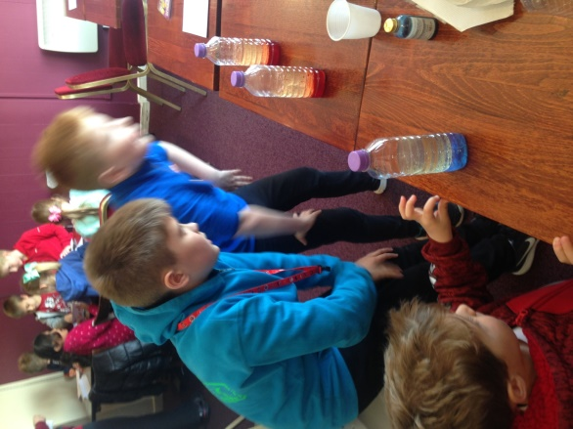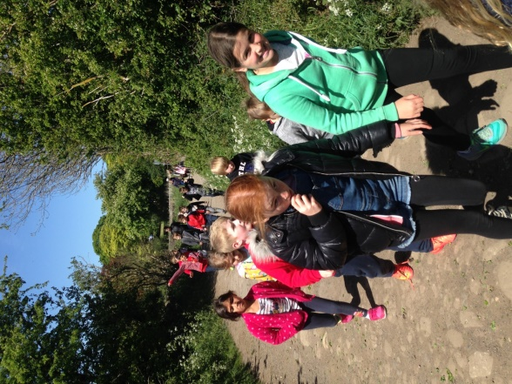

**Starfish Gang**

The Starfish Gang enjoyed preparing for the family service in March when we were thinking about Jesus in the Wilderness. We try to concentrate on a bible story for more than one Sunday which both the children and leaders are enjoying. The leaders are meeting regularly to organise and prepare for the Starfish Gang.

**Family Events**

The joint event of ten pin bowling with families from Herringthorpe is popular, a picnic at Clumber Park was planned but unfortunately had to be cancelled due to the weather and not many families going. The annual Cleethorpes Trip is booked and planned for the first Saturday in September; this is a lovely day for all the church families at Whiston and Herringthorpe.

**Open the Book**

WOW, we went into Whiston Worrygoose Junior and Infant school at the end of May to the assembly when 9 volunteers from Whiston Church attended to perform Open the Book. The first story was about God’s Creation, both the children and staff thoroughly enjoyed this and the headteacher was very keen for us to do this on a regular basis. Our next visit is tomorrow! From September Whiston J & I also want us to go in with Open the Book. This is very exciting; we plan to go in both schools on a Thursday once a month. If anyone is interested in being involved please speak to me.

Again it has been a busy enjoyable few months, as well as the above I have attended monthly Centenary Project Network meetings which are held at the churches of the Centenary Project Workers, we met at Whiston in March. I also attend trainings, and regularly meetings with Dhoe and Karen. Each month I record figures for the Centenary Project, the figures are all age related of children who attend any of the activities I lead together with the number of volunteers.

All in all Children’s and Families work at Whiston is going very well with many families enjoying activities on offer.